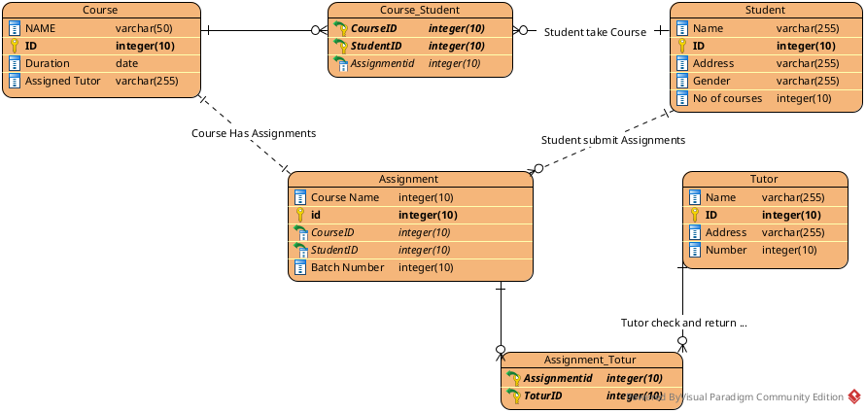

#Doc

Let’s create a Entity for our Course having attributes (Name, Id, Duration, Assigned Tutor ). Name refers to the name of course , ID refers to the unique id of the course. Duration refers to the time required to complete the course and Assigned toutor for the teaching.

Entity name Student is created with there Name , ID, Address, Gender, Number of courses.

Entity name Assignment is created with Course Name, ID, Batch Number Attributes.

Entity name Tutor is created with Name, ID, Adress, Number attributes.

Now for the relationship

Course have the many to many relation with students so a new relation entity is forced created naming Course_Student having primary key of both entity. Course also have one to one relation with Assignment as each course have there one assignment.

Student entity have one to many assignment with the student as single student have to deal with many assignment .

Assignment and Tutor have many to many relationship as a single teacher can check many assignment as well as a single assignmet can be cheked by many tutor.

